# **BALLON BLEU DE CARTIER WATCH**

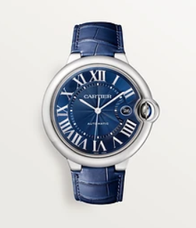Product Details:

Ballon Bleu de Cartier watch, 42 mm. Mechanical movement with automatic winding, calibre 1847 MC. Steel case, fluted crown set with a synthetic cabochon-shaped spinel, blue guilloché dial. Sword-shaped hands, sapphire crystal, blue alligator-skin strap, and interchangeable steel folding buckle.

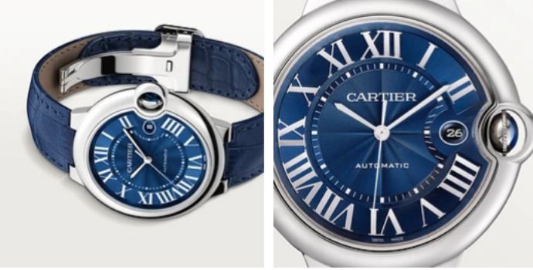

Calendar aperture at 3 o'clock. Thickness: 13 mm. Water-resistant to 3 bar (approx. 30 meters).